**GIT COMMIT & PUSH process**

Part 1 – How to resolve merge conflict issues which happens when 2 resources are working on the same line of code.

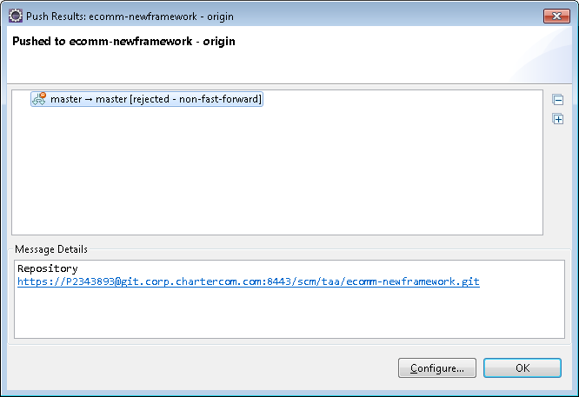

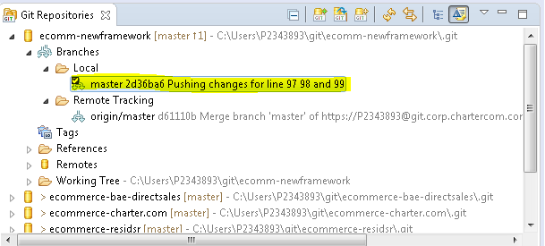

Now right click on project name and click on **Team 🡪 Pull**

Once done, you may see **Conflicting** result

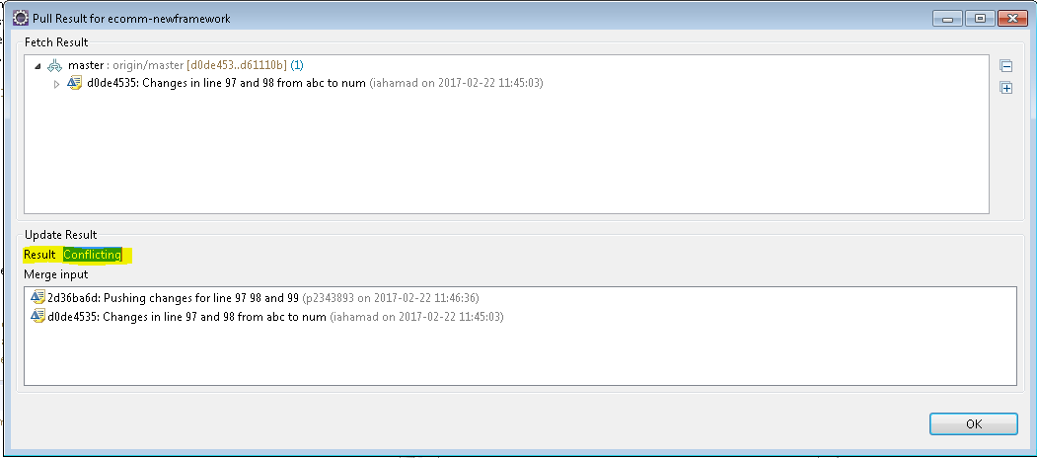

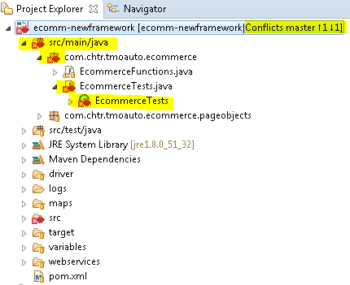

Screenshot of code

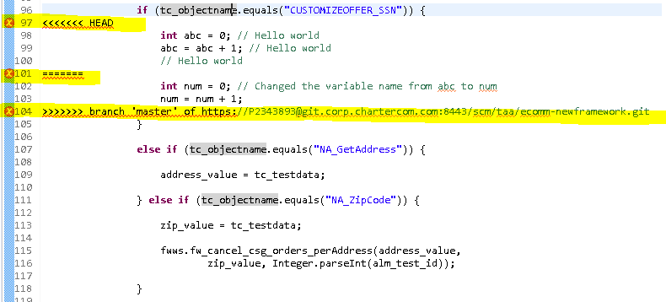

Code between **<<<<<<< HEAD** and ======= are local user’s changes

Code between **=======** and **>>>>>>> branch 'master' of** [**https://P2343893@git.corp.chartercom.com:8443/scm/taa/ecomm-newframework.git**](https://P2343893@git.corp.chartercom.com:8443/scm/taa/ecomm-newframework.git)are the changes available in GIT committed by other Developer.

Look for other similar pattern which may show up as a conflict on some other line.

**RESOLUTION**

Remove the << HEAD and ==== and >>>>

Keep the code which you want to actually commit. In this case I removed all the comments and renamed the variable from abc to num.

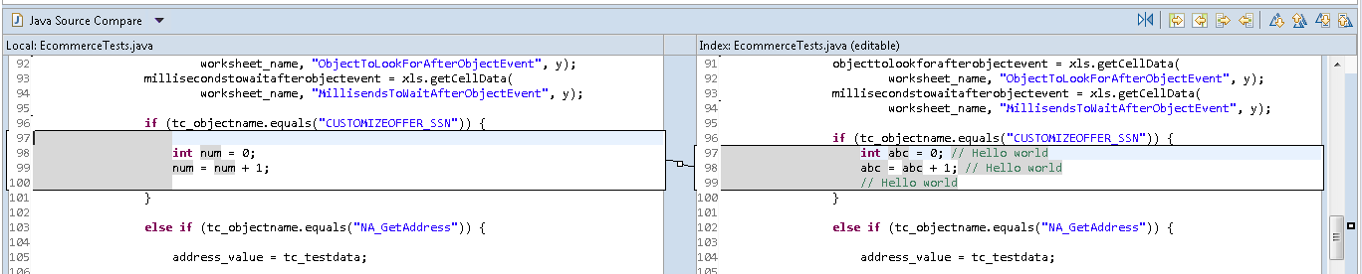

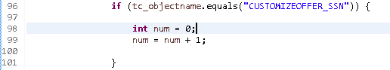

Now again try to push this file to GIT.

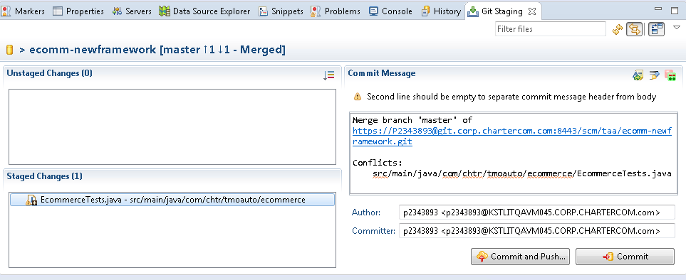

Part 2 – How to resolve merge issues when 2 resources are working on the different lines of code.

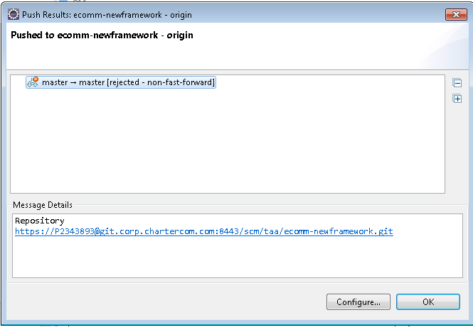

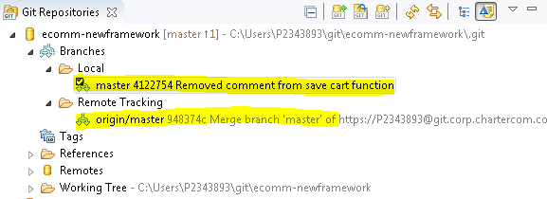

Now right click on project name and click on **Team 🡪 Pull**

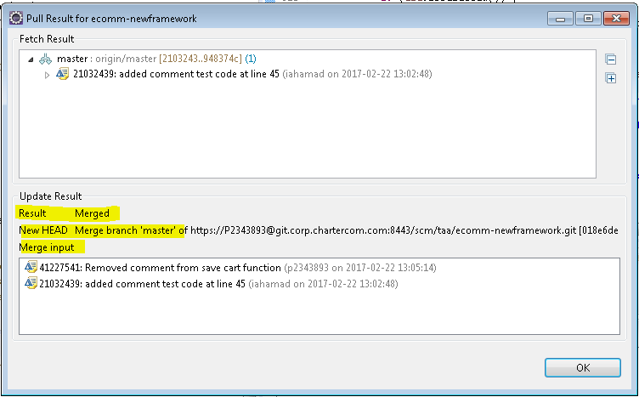

Now under **GIT repositories** view, right click on **Local master branch** and select **Push Branch…** option

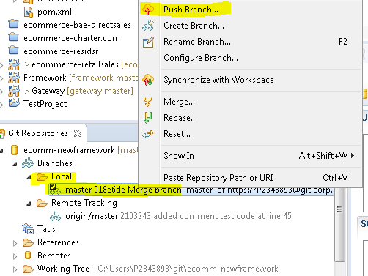

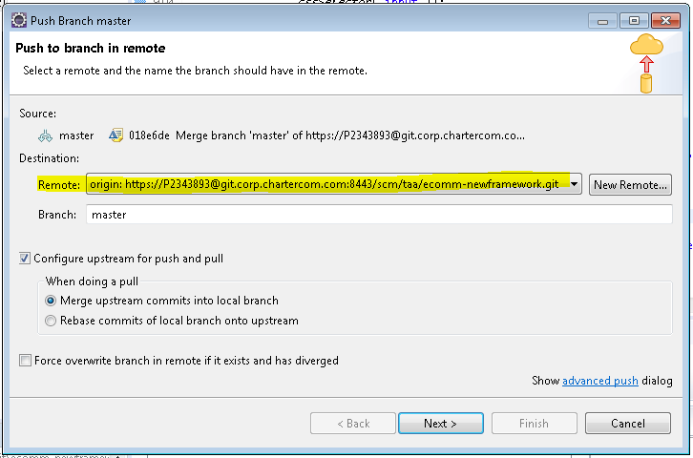

Input the password for the User and click on OK.

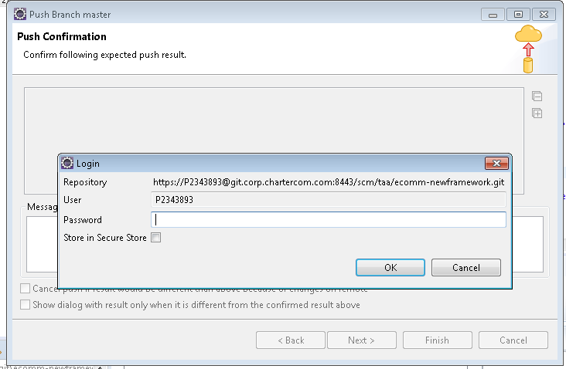

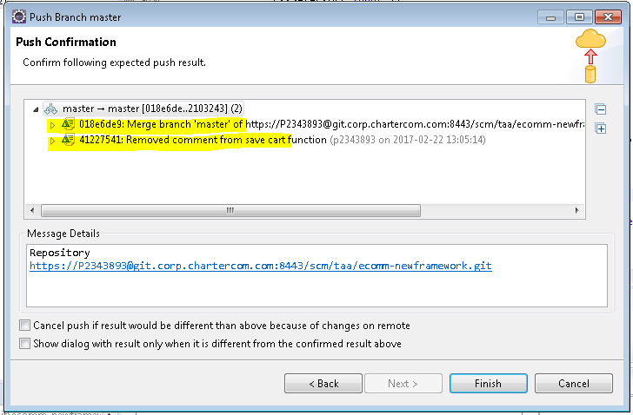

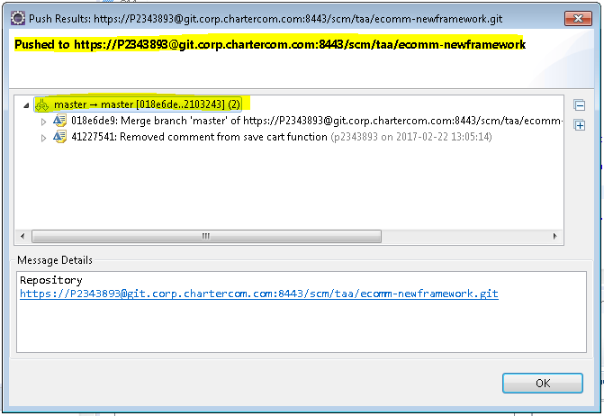

After push is confirmed, you can see that Local and Remote branches are having same id.

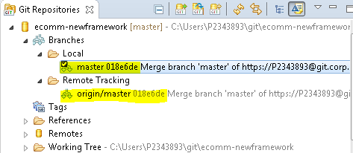

Part 3 – How to resolve merge issues when 2 resources are working on EXCEL files.

Dev 1 added a new object in the object tab.

Dev 2 modified something in the TC tab.

How to merge the changes of these 2 Developers and resolve the conflict issue?

**RESOLUTION**

1. Take back-up of the excel config map file once your changes are completed and store it locally.
2. In eclipse, Right click on excel config map file and select **Replace With** 🡪 **Commit**

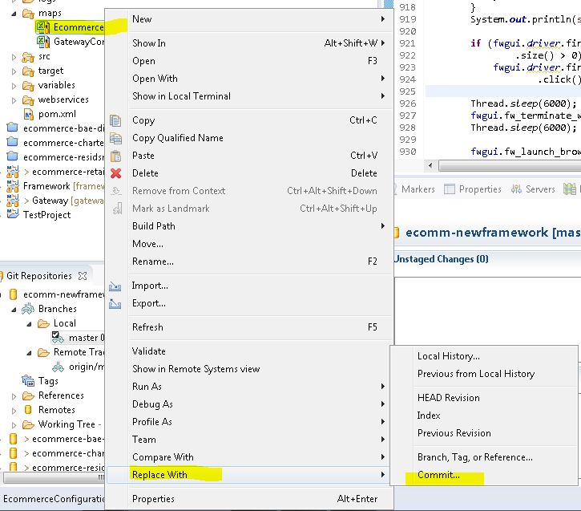

1. Click on OK on the below message.

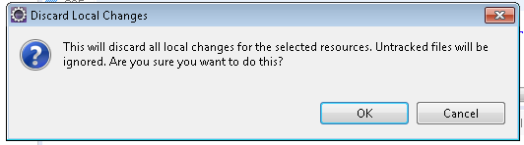

1. Pick the latest commit by looking at the Authored Date column.

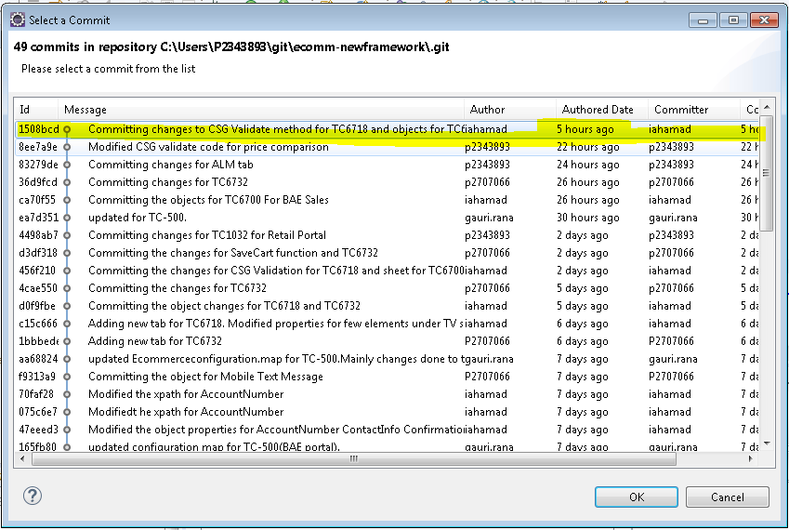

1. Now the changes are reverted back. Right click on project name and click on Team 🡪 Pull to the get the changes committed by other Developer for the excel config map file.

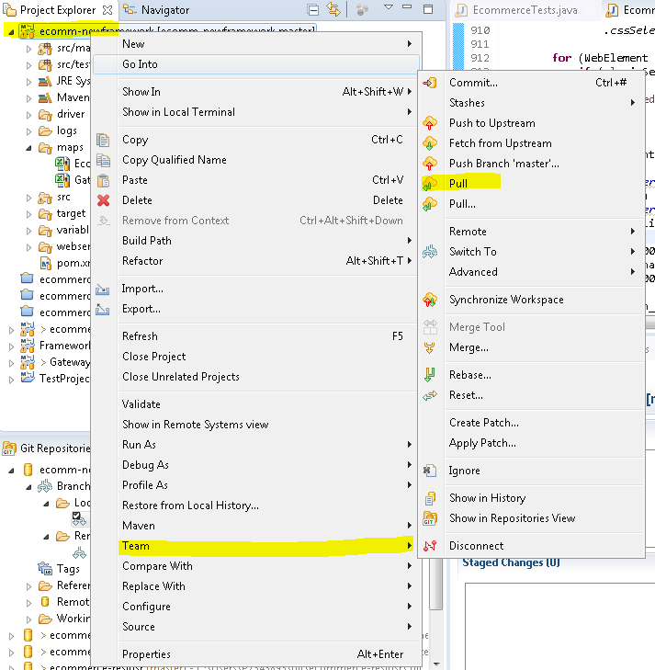

1. Now you have the latest changes.